 Translated from Chinese (Simplified) to English - www.onlinedoctranslator.com

180GSpecifications
(Material Name180KG Single Door Magnetic Lock

- Brand and Manufacturer Information
  - Manufacturer: Zhongshan Ju'an Shield Electronic Lock Industry Co., Ltd.
  - Logo:

- Material model and version
- Model: 180G
- Version:

- Main functions and features
This product is noiseless, wear-free, has no mechanical failures, strong suction, and a longer service life. The lock body is made of selected...
Treated with specialized magnetizing materials and processes, it does not produce residual magnetism during prolonged operation and is not susceptible to magnetism after long-term use.
The magnetization of the plate weakens the suction force. The aluminum material is anodized, while the lock body and suction plate are electroplated to improve adhesion.
It is stronger and has better corrosion resistance.

- Technical parameters
Model: 180G
Lock body dimensions: 168×40×21.5(mm)
Suction plate dimensions: 140×33×11.5(mm)
Working principle: Locks when powered on, unlocks when powered off.
Operating voltage: DC 12V ±10%
Operating current: 330mA
Power: 4W

Operating temperature rise: ≤ Ambient temperature + 15℃

Static tensile force: 180 kg

Indicator lights: None

Operating life: 1 million cycles

Ambient temperature: -20～55℃

Lock body materials: silicon steel sheet, pure copper enameled wire, aluminum alloy

Suction plate material: Electrical pure iron

- Product view (exterior view)

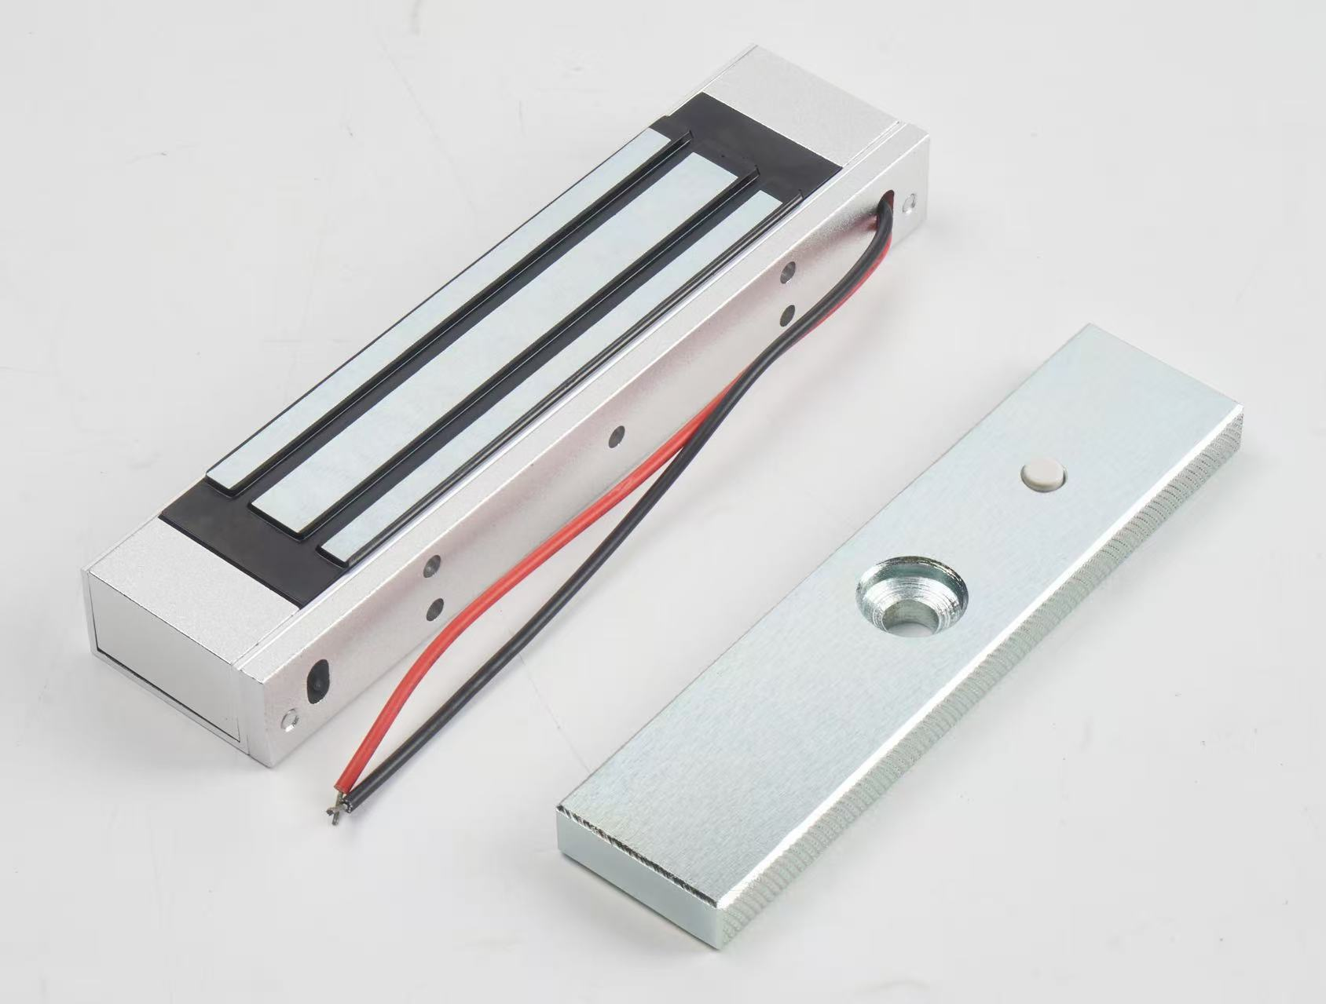

Model: 180G

- Product Certification Qualification (Laws and Regulations) Explanation
According to the National Security and Alarm System Product Quality Supervision and Inspection Center (Shanghai)
Testing by the Product Quality Supervision and Inspection Center of the Ministry of Public Security's Security and Alarm System

- Structural dimension drawing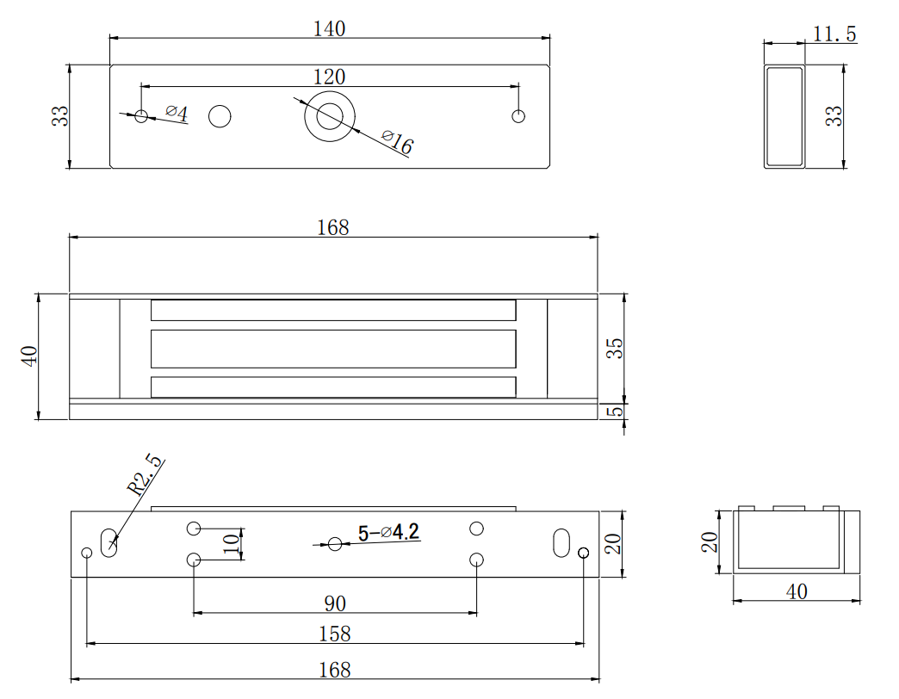

Note: All dimensions are in mm.

- Bill of Materials
name | Quantity (units)
180G lock body | 1
Vice board | 1 piece
M8*30mm mushroom head screw | 1 piece
M8*50mm Phillips head screw | 1 piece
M4*30mm Phillips head countersunk screws (for wooden doors) | 5
Φ20*10*1mm rubber sheet spacer/white gasket | 1
4.6 cents spoon | 1
4*12mm spring pin | 2
manual | 1 copy
Certificate of Conformity | 1 copy
Desiccant | 1
Hole positioning paper | 1 copy

- Packaging method and outer box labeling

Model: 180G

Net weight of a single lock: 1kg

Total quantity: 24 pieces

Total net weight: 25kg

Outer box dimensions: 39*21.5*25

Note: Production batch number and production date are subject to the actual goods.

- Storage and transportation requirements
conventional

- Product warranty and service (optional)
Two-year warranty.

